***PROJECT***

***DATABASE MANAGEMENT SYSTEM***

***ARI DIKOLLI***

***SOFTWARE ENGINEERING 2***

***Data base of Ari’s Events Planning Company***

**Abstract:**

This database is created in order to make the events planning business a digital one.

This system will help the company to extend not only in the physical place where it is located but in all cities of Albania and even abroad.

Main actors of this project will be 3: the customer the business and the planner. They will be closely related to each other. Once a new customer enters the system, he will find a bunch of services offered to him such as photo, video, restaurant, deejay and so on. If we find it difficult to choose a business, they will be a number of planners ready to help the customer. The planner will suggest any company for the service that the customer is looking for. Based on the planner suggestion and the advertisement that this company has published in its profile, the customer will be able to decide for the company.

The database will also keep track of the prices paid from customer. So, after some month or years of using this database, the new customers will somehow know the average prices for all companies that are part of our database, based on previous years activity.

In total there will be 7 entities (main 3 of them are mention above).

The main goal of this database is to set the planning business a step further.

***Introduction:***

I have chosen this business because I have been in this field for more than 5 years already. Nowadays, there is not a planning company that allows all businesses from all over Albania to be part of it and offers to the customer a wide variety of choices available. This is what my database is planning to do, to make things easier and more practicable.

Every business related to that field can enter to that database. They will have a unique ID, a name and the place where they will be located. An important part for businesses is that each business has to provide an advertising tool such as a short video, or photo, or a sound material. Each customer that is part of the database can see all the businesses for the category in which he is interested. He can even search by the city in order to find all services that are offered in his city.

When the customer is not sure or can not decide for a certain business, he can ask a planner for help. Planners are persons that are parts of the database. These planners will suggest the most appropriate business to customer based on the price, place located or other requirements.

The system is supposed to be easy to use, efficient and very helpful for both businesses and customers. This database will keep the information in a sophisticated manner and will be easy to access this information at any time needed.

***The purpose of this project is:***

1. To learn how to keep track of the database in planning events, a big system that stores information for customers and businesses and create an interconnection between these two entities.
2. To make planning a digital business.

***The goal for that project is:***

1. To construct the database for event planning business including all entities, and relationships between all entities.
2. To calculate monthly or yearly revenue for all businesses.
3. To be able to store and retrieve information from the database in an effective way.

***Business Description:***

***Describing the organization:***

I want to create an online – platform that will be used from all people who are planning

to organize an event such as: weddings, birthdays, parties and so on. There will be two

main parts included in this platform: the customers and the businesses. A customer will

find different services and products through this platform such as: restaurants,

photographers, hairdresser, clothes, cars, flowers etc. On the other hand are

businesses that are going to advertise their own work through this platform. Each of

businesses included will have its own profile in which will post their work and a brief

description for themselves. There are going to be even some “planner”. There are some

persons that will contact with customers once they are unsecure. Planners will suggest

some different companies included in the platform for a specific service based on the

reviews that these companies have had during last years. Finally, there will be a

payment option. Once a customer decide for a specific service, he is going to pay online

for it. There will be several payment methods available such as: MoneyGram, PayPal,

Western Union etc.

***Describing the scope:***

The scope of this platform is to give the opportunity to everyone to organize its own

events in the best way possible in no time. If someone is busy and does not have a lot

of time to spend for finding the perfect photographer, this platform will give him/her the

opportunity to book him in no time while having a coffee break. Through this platform

everything will be clear and secure. So, once the customer and the business will agree

they will sign an online contract in which will be included the signature of both parts and

the conditions that they agreed. In such way, when the date of the events comes, there

will be no place for exploitation or misunderstanding. In this way, everything will be

easier for clients to choose their favourites businesses and not to lose time. Also, the

platform will make sure that all photos and videos that will be unloaded from the

businesses will be unique and will not belong to any other company. In this way there

will be no opportunity for a customer to get deceived.

A GANTT CHART :

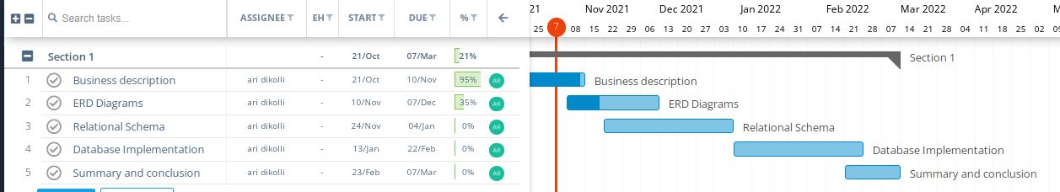

**Processes/operations supported by the proposed database**

1. Customer, who wants to book for an event can access the database and find the businesses that are available for that date, can check for the quality and price and can book a specific business.
2. When customers are having difficulties in choosing a specific business, they can request the help of a planner, who basically will recommend to the client a specific business.
3. Different businesses in different fields such as music companies, filming industries and décor companies can join the database.
4. Each business category has different businesses which are located in different cities, so that database can show all businesses for a specific category in a specific city, making the decision easier for customers.
5. Each business, customer and planner joined will have its unique ID, so that the manager will find it easier to organize the database.
6. In conclusion, the database will enable a daily / monthly / annual calculation of profits for businesses which will also underline the most required businesses and services, in order to

make an accurate balance of consumer demand.

***List of Managerial Queries:***

The manager wants to know:

1. The service that is purchased, customer full name who purchased that service, the method he paid, the business name he booked and the price for all services whose price is less than the average of all service booked prices
2. Business name and business price for the cheapest business in “Wedding” industry.
3. The total amount of money that have been paid through each of payment methods.
4. The customer’s name, customer id and for each customer, the planner’s name and planner id that has helped this customer.
5. The business which has earned the largest amount of money and the customer who has paid this amount.
6. All the businesses found in a specific city (Suppose Korca).
7. All the DJs information (DJ id and DJ full name) that are cheaper than 500 $.
8. Business name, business id and place where this business is located for all businesses that have uploaded photos as their advertisement method.
9. All the planner’s information (Planner ID and Planner name) sorted by alphabetical order by planner’s name.
10. A general table which consists of customer information (customer full name and id), business information (business id, business name and the place where business is located), payment method that the customer choose. All this table should be sorted by alphabetical order by business name.

***Entities and their attributes:***

**Entity Planner:**

This entity is for all planners that are part of the database.

**Primary key** is a key in a relational database that is unique for each record. In relation Planner primary key is **PlannerID**, which is unique for each place part of the database.

**PlannerFname**: This attribute holds the first name of the planner.

**PlannerLname**: This attribute holds the last name of the planner.

**PlannerEmail**: This attribute holds the email address of the planner.

**PlannerPhoneNR**: This attribute holds the phone numbers of the planner (it is a multivalued attribute).

**Entity Customer:**

This entity is for all customers that are part of the database.

**Primary key** is a key in a relational database that is unique for each record. In relation Planner primary key is **CustomerID**, which is unique for each place part of the database.

**CustomerFname**: This attribute holds the first name of the customer.

**CustomerLname**: This attribute holds the last name of the customer.

**CustomerEmail**: This attribute holds the email address of the customer.

**CustomerAddress**: This attribute holds the address of the customer.

**CustomerGender**: This attribute holds the gender of the customer.

**CustomerPhoneNR**: This attribute holds the phone numbers of the customer (it is a multivalued attribute).

**Entity PlaceLocated:**

This entity is for the places where businesses that are part of the database are located.

**Primary key** is a key in a relational database that is unique for each record. In relation placeLocated primary key is **PlaceID**, which is unique for each place part of the database.

**Placename**: This attribute holds the name of the place.

**Entity: Business**

This entity is for all businesses that are part of the database.

**Primary key** is a key in a relational database that is unique for each record. In relation business primary key is **businessID**, which is unique for each business part of the database.

**BusinessName**: This attribute holds the name of the business.

**BusinessregistrationDate**: This attribute holds the date when the business is registered in the database. (This is derived attribute).

**Foreign Key**: PlaceID. This foreign key acts as a cross reference between tables because it is referencing to another entity. (To entity placeLocated).

**Entity: ‘Promovation’**

This entity is for all advertisement that businesses that are part of the database have made.

**Primary key** is a key in a relational database that is unique for each record. In relation ‘promovation’, primary key is **PromoID**, which is unique for each promovation part of the database

**PromoDescription**: This attribute holds the description of the promovation.

**PromoDate**: This attribute holds the date when the promovation is registered in the database.

**Foreign key**: Business this foreign key acts as a cross reference between tables because it is referencing to another entity. (To entity Business).

Entity Payment:

This entity is for all payment that customer have made toward businesses.

**Primary key** is a key in a relational database that is unique for each record. In relation ‘Payment’, primary key is **PaymentID**, which is unique for each payment part of the database.

**PaymentDate**: is the date when the payment happened.

**PaymentDescription**: is the name of the bank through which the payment was done (ex PayPal, Western Union etc).

**PaymentPrice**: the price that the customer has paid.

**Foreign Keys**: BussID, CustID. This foreign key acts as a cross reference between tables because it is referencing to another entity. (To entities Business and Customer).

Entity ServicePurchased:

This entity is for all services that have been purchased from customers.

**Primary key** is a key in a relational database that is unique for each record. In relation “ServicePurchased” primary key is **ServiceID**, which is unique for each service that is purchased.

**ServiceDesctiption**: Is the description for the service that is purchased.

**ServicePurchasmentDate**: is the date when the service is purchased. (This is derived attribute).

**Foreign Keys**: BussID, CustID. This foreign key acts as a cross reference between tables because it is referencing to another entity. (To entities Business and Customer).

**Relationship Description:**

**Located** (The primary key of table placeLocated is as a foreign key in table Business since it is a one-to-many relationship.)

A business can be located just in one place. On the other hand, a specific place can hold one or a lot of businesses

**Contains** (The primary key of table Business is as a foreign key in table promovation since it is a one-to-many relationship.)

A business can have one or several promo advertisements but a specific advertisement belongs only to one business.

**Involve** (The primary key of table business is as a foreign key in table Payment since it is a one-to-many relationship).

A payment is made in just one business. On the other hand, a business can take one or several payments from the customer.

**Transferred** (The primary key of table business is as a foreign key in table ServicePurchased since it is a one-to-many relationship).

In a business can be made one or a lot of purchases.

On the other hand, a specific purchase belongs to one and only one business.

**Purchase** (The primary key of table customer is as a foreign key in table ServicePurchased since it is a one-to-many relationship)

A customer can purchase one or several different services.

On the other hand, a specific service is purchased by only one customer.

**Pay** (The primary key of table customer is as a foreign key in table Payment since it is a one-to-many relationship)

A customer can make one or several payments towards businesses.

On the other hand, a specific payment is made by one and only one customer.

**Advise** (Include two foreign keys which are respective primary keys of the table it connects. In this case these foreign keys come from table Customer and Planner)

A customer can choose between one or many planners.

A planner can advise one or more customers at the same time.

***ER DIAGRAM***

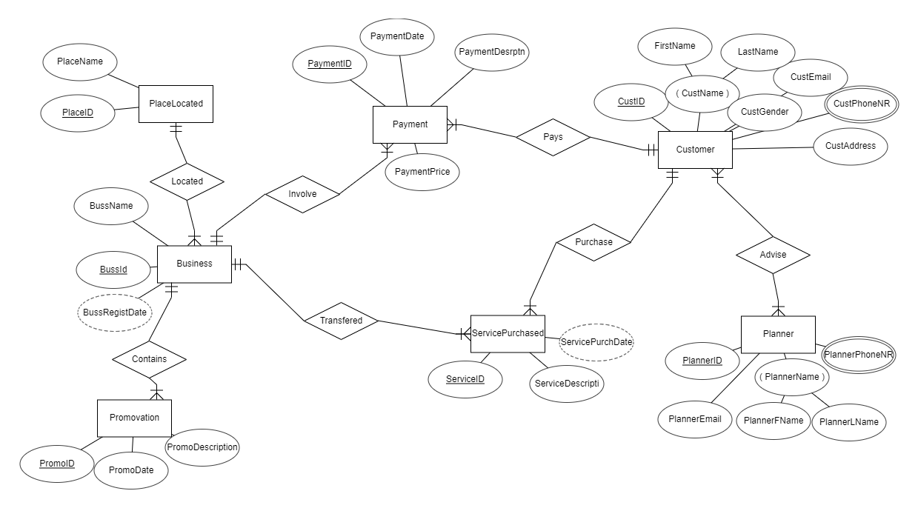

**Relational Schema:**

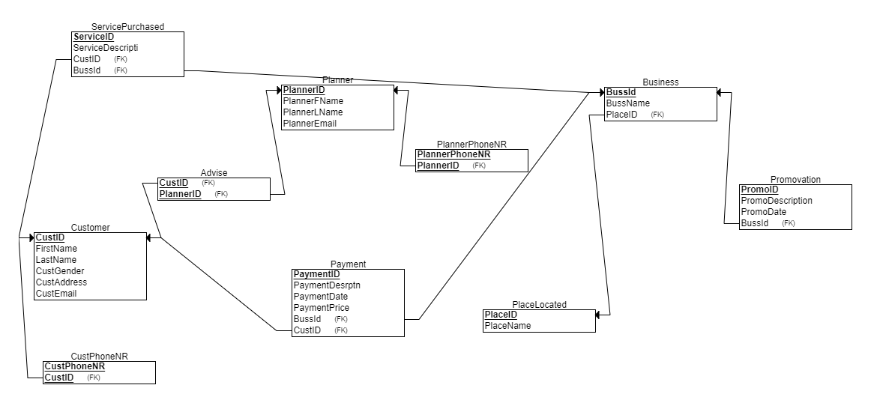

***CONCLUSIONS***

Finally in event planning management system, we have a database where customer come, see the business available and after taking the advises from the planners he decide for the business that has to book. Businesses that are registered in the database are more than enough to satisfy all the customers needs. If we implement this database successfully will make easier for customer to decide for the business that they will book in their events and will also help a lot of businesses to gain more customers.

To sum up, a database is the future tool for saving and organizing data. This database will make this planning event company faster, more accessible and easier to use from the vast majority of customers.